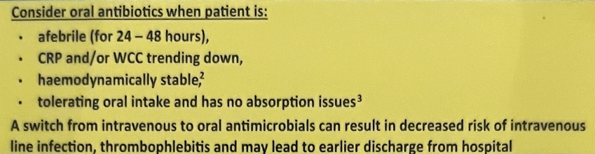
ANTIBIOTIC STEWARDSHIP
- Source checking – likely cause?
- Empiric ABx or other ABx used in past 13 days
- Pathogen resistance (M/C/S)
- Sensitivities to abx (i.e. anaphylaxis, angioedema)
- Indwelling devices
- Special considerations? – immunodef, recent surgery

RESPIRATORY |  |  | Step Down
CAP inc. aspiration  (w/ CXR changes)  Treat for 7 days total | Low severity | - Amoxicillin 1g TDS PO +/- doxycycline 100mg PO BD | nil
 | Mod severity | - Benpen 1.2g QID IV + doxycycline 100mg PO BD | Amoxicillin TDS
 | Sev severity | - Ceftriaxone 2g IV OD + azithromycin 500mg IV OD (3-5 days) | Specialist advice  Amoxicillin TDS  Cefuroxime 500mg PO BD (if penicillin allergy)  Azithromycin PO daily
HAP  Treat for 7 days total | Low MRO risk + mild | - Augmentin PO BD  - Cefuroxime 500mg PO BD  - Ceftriaxone 1g IV daily (if oral not tolerated) | Augmentin PO BD
HAP  Treat for 7 days total | High MRO risk + mod/severe | - Pip-taz 4.5g IV q6hrly +/- vancomycin (if MRSA risk) | Specialist advice Augmentin PO BD
HAP  Treat for 7 days total | Anaerobe risk | - Ceftriaxone 2g IV daily + Metronidazole 500mg IV q12hrly  (i.e. severe periodontal disease, lung abscess, empyema, large parapneumonic effusion, necrotising pneumonia) | Specialist advice Augmentin PO BD to complete course  Metronidazole 400mg PO BD (if needed)
CENTRAL NERVOUS SYSTEM
Bacterial meningitis | General | - Ceftriaxone 2g IV BD + dexamethasone 10mg IV q6hrly  (ideally dex before ceftriaxone) | Augmentin PO BD to complete course
Bacterial meningitis | Special considerations | - Listeria risk – add benpen 2.5g IV q4hrly  - B-lactam resistant streptocci – add IV vancomycin | Amoxicillin TDS
HSV encephalitis |  | - Acyclovir 10mg/kg IV q8hrly (14-21 days) | Specialist advice
GASTROINTESTINAL SYSTEM
Cholangitis / acute acalculous cholecystitis | General | - Ampicillin 2g IV q6hrly + gentamicin STAT  (if gentamicin CI --> replace with 2g ceftriaxone IV daily) | Augmentin PO BD to complete course  Metronidazole 400mg PO BD (if needed)
Cholangitis / acute acalculous cholecystitis | Chronic biliary obstruction | - Add metronidazole 500mg IV q12hrly
Cholangitis / acute acalculous cholecystitis | Cholangitis | - 5 day course (post biliary drainage) OR 7-10 days (if not for drainage)
Diverticulitis / peritonitis 2º perforation | General | - Ampicillin 2g IV q6hrly + Gentamicin + Metronidazole 500mg IV q12hrly  (if gentamicin CI --> replace with 2g ceftriaxone IV daily)
Diverticulitis / peritonitis 2º perforation | Severe | - Pip taz 4.5g IV q6hrly | Specialist advice
GENITOURINARY TRACT
Acute cystitis | General | - Trimethoprim 300mg PO daily (3 days - female, 7 days – male) | nil
Acute cystitis | If recent ABx | - Cefalexin 500mg PO BD (5 days - female, 7 days – male) | nil
Acute pyelonephritis | Mild | - Augmentin PO BD for 10-14 days | nil
Acute pyelonephritis | Severe | - Ampicillin 2g IV q6hrly + gentamicin STAT  (if gentamicin CI --> replace with 2g ceftriaxone IV daily) | Based on MCS  Cefalexin 500mg PO BD (if sensitivities unsure)
SKIN & SOFT TISSUE INFECTIONS
Cellulitis  (for 5-10 days) | Mild | Flucloxacillin 500mg PO QID for 5 days | nil
Cellulitis  (for 5-10 days) | Moderate (outpatient/HITH) | Cefazolin 2g IV daily + probenecid 1g PO daily (increase circulating volume of cefazolin by reducing renal tubular excretion) | Cefalexin 500mg PO QID
Cellulitis  (for 5-10 days) | Severe (admission) | IV flucloxacillin 2g IV q6hrly OR cefazolin 2g IV Q8hrly  - add IV vancomycin if MRSA risk | Flucloxacillin 500mg PO QID
*avoid PO therapy as initial Rx for meningitis, endocarditis, osteomyelitis, septic arthritis, S. aureus bacteremia
**Gentamicin 7mg/kg (if septic shock) and 4-5mg/kg IV (impaired renal function)
- avoided in: renal impairment, pregnancy, ototoxicity risk, neuromuscular disease (MG, MND – as aminoglycosides worsen neuromuscular blockade), elderly patients, or when prolonged therapy or drug level monitoring is required
***Vancomycin IV = 25mg/kg loading dose then 15mg/kg IV BD (if normal renal function + BMI < 30) → check trough level immediately prior to 4th dose
****Escalating to carbapenems – covers ESBL producing enterobacters, anaerobes (exc. ertapenem)) - but NOT MRSA, VRE

